**Assignment: Python Programming for GUI**

**Development**

Name: P.Vinay Kumar

Register Number: 192324186

Department:B.Tech-AI&DS

Date of Submission: 26.08.2024

**Problem: Air Pollution API**

1. Current, forecast and historical air pollution data
2. Forecast for 4 days ahead with 1-hour step
3. Air Pollution API includes both Air Quality Index and indices for CO, NO, NO2, O3, SO2, NH3,PM2.5, PM10 .
4. Included in both free and paid subscriptions

**Deliverables:**

1. Data flow diagram illustrating the interaction between the application and the API .
2. Pseudo code and implementation
3. Documentation of the API integration and the methods used to fetch and display the data.
4. Explanation of any assumptions made and potential improvements

**Solution:**

## Air Pollution API

**1. Data Flow Diagram**

**Start**

**Import requests**

**Get air pollution Data**

**Get data from URL**

**Send HTTP request**

**Prase JSON Data**

**Extract AQI**

**Print AQI and Pollutants**

**End**

**2. Implementation**

import requests

def get_air_pollution_data(api_key,lat,lon):

url =

f"http://api.openweathermap.org/data/2.5/air_pollution?lat={lat}&lon={lon}&appid

{api _ key}

response=requests.get(url)

if response.status_code==200:

data=response.json()

aqi=data['list'][0]['main']['aqi']

components=data['list'][0]['components']

print("Air Quality Index (AQI):", aqi)

print("Concentration of pollutants in µg/m³:")

print("CO:", components['co'])

print("NO:", components['no'])

print("NO2:",components['no2'])

print("O3:",components['o3'])

print("SO2:",components['so2'])

print("PM2.5:",components['pm2_5'])

print("PM10:",components['pm10'])

print("NH3:",components['nh3'])

else:

print("Failed to retrieve data. HTTP Status code:", response .status _code)

if _name_ == "_main_":

api _ key = "7388dca5f7653c38ee1f85baa3f7a900"

lat = "37.7749"

lon = "-122.4194"

get _ air _ pollution _data( api _key, lat, lon)

**3. Display the air pollution information**

Air Quality Index (AQI): 1

Concentration of pollutants in µg/m³:

CO: 220.3

NO: 0.5

NO2: 3.26

O3: 49.35

SO2: 0.54

PM2.5: 1.79

PM10: 3.67

NH3: 0.05

**4. User Input**

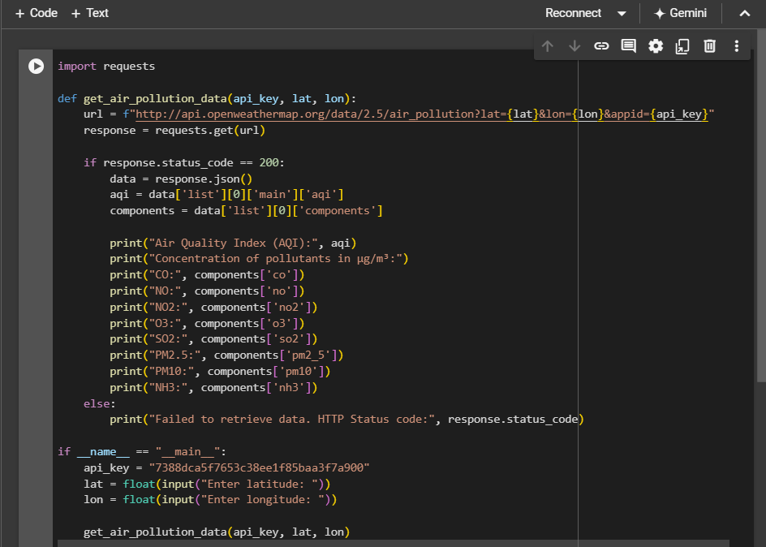

**5. user output:**

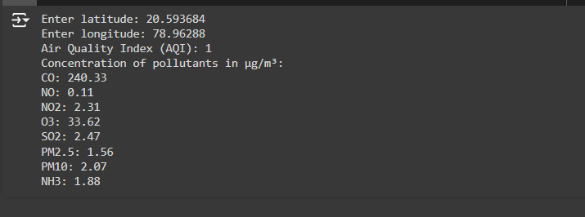

**6. Documentation**

**Explanation of the code:**

**Imports**: Uses the `requests` library to make HTTP requests.

**Function Definition**: `get_air_pollution_data (api _key,lat ,lon)` fetches air pollution data from OpenWeatherMap based on latitude and longitude.

**API Request**: Constructs a URL with the API key and coordinates, then sends a GET request to the API.

**Response Handling**: Checks if the request was successful (status code 200). If so, parses the JSON response.

**Data Extraction**: Retrieves the Air Quality Index (AQI) and pollutant concentrations from the response.

**Output**: Prints the AQI and concentrations of pollutants in µg/m³.

**Error Handling**: If the request fails, prints an error message.

**Usage Example**: Replaces `"YOUR_API_KEY"` with your actual API key and specifies the coordinates to fetch and display the data.